SANDAG ABM2+ Application Tool User Guide

August 2022 | Prepared for San Diego Association of Governments



Report Title
SANDAG ABM2+ Application Tool User Guide
Report Prepared by
RSG
Report Prepared for
San Diego Association of Governments
For additional information regarding this report, or for questions about permissions or use of findings contained therein, please contact
RSG
1111 6th St. Suite 300
San Diego, CA 92101
802.295.4999
www.rsginc.com
© 2022 RSG

Notice of Rights
All rights reserved. No part of this report may be reproduced or transmitted in any form by any means, electronic, mechanical, photocopy, recording, or other without the prior written permission of RSG.
© 2021 RSG

1.0 Introduction 1
2.0 The ABM2+ Application Tool 6
2.1 The Tool 6
2.2 Setup Requirement 8
3.0 Project Initiation and Setup 10
Task 4: Client Request 10
Task 5: Prepare Cost and Time Estimate 10
Task 6: Setup a Project Directory 10
4.0 Run the Project 14
Task 7: Define Project with Client 14
Task 8: Update TAZ Split Related Inputs 15
Task 9: Update Model Inputs 16
Update Settings in Master Batch File 17
Run Master Batch File 28
Quality Assurance/Quality Control Outputs 29
Task 10: Run Models 32
5.0 Evaluation and Reporting 33
Task 11: Run Reports 33
Task 12: Deliver To Client 33
Task 13: Invoice and Closeout 33
6.0 Example Project 1 – Mission Valley Home Depot 34
Task 4: Define Project with Client 34
Task 5: Update TAZ Split Related Inputs 35
Task 6: Update Model Inputs 35
Update Settings in Master Batch File 35
Run Master Batch File 38
Quality Assurance/Quality Control Outputs 39
Task 7: Run Models 41
7.0 Example Project 2 – Naval Information Warfare Systems Command High-Density Development 42
Task 8: Define Project with Client 42
Task 9: Update TAZ Split Related Inputs 44
Task 10: Update Model Inputs 45
Update Settings in Master Batch File 45
Run Master Batch 48
Quality Assurance/Quality Control Outputs 48
Task 11: Run Models 51
List of Figures
Figure 1: ABM2+ Application Tool Process for the Service Bureau 3
Figure 2: ABM2+ Application Tool Storage Directory 7
Figure 3: Extract 'miniforge.zip' 8
Figure 4: Mambaforge Installation 9
Figure 5: Setup Software Requirements From Batch File 9
Figure 6: Create Setup batch Script – Update Paths 11
Figure 7: Create Folder Setup from Batch File 11
Figure 8: Project Directory Structure 12
Figure 9: Client Input for ABM2+ Application Tool 15
Figure 10: Global Settings 18
Figure 11: Run Create Baseline Setting 20
Figure 12: TAZ Split Settings 20
Figure 13: Land Use Converter Settings 22
Figure 14: Synthetic Population Settings 24
Figure 15: Household Sampling Settings 27
Figure 16: Run Master Batch File 29
Figure 17: landuse converter – HTML File (Land Use Data Tab) 30
Figure 18: land use converter – HTML FIle (Map TAB) 31
Figure 19: Household Sampling - Sample Rate Map 31
Figure 20: Household Sampling - QA/QC Spreadsheet 32
Figure 21: Client Land Use Form – Home Depot 35
Figure 22: Project Summary – Home Depot 35
Figure 23: Global Settings - Home Depot 36
Figure 24: Create Baseline Settings 36
Figure 25: Land Use Converter Settings - Home Depot 37
Figure 26: Household Sampling Settings - Home Depot 38
Figure 27: Run Application Tool - Home Depot 38
Figure 28: Land Use Data Tables - Home Depot 40
Figure 29: Land Use Update Spatial Map - Home Depot 40
Figure 30: Sample Rate Map - Home Depot 41
Figure 31: Home Depot Household Sampling Check 41
Figure 32: Client Land Use Form – NAVWAR 43
Figure 33: Project Summary – NAVWAR 44
Figure 34: Hotel Room Shares 44
Figure 35: Global Settings - NAVWAR 45
Figure 36: Land Use Converter Settings - NAVWAR 46
Figure 37: PopulationSim Settings - NAVWAR 47
Figure 38: Household Sampling Settings – NAVWAR 47
Figure 39: Run Application Tool - NAVWAR 48
Figure 40: Input Update Log File – NAVWAR 49
Figure 41: Land Use Data Tables – NAVWAR 49
Figure 42: Land Use Update Spatial Map – NAVWAR 50
Figure 43: Sample Rate Map – NAVWAR 51
Figure 44: NAVWAR Household Sampling Check 51

List of Tables
Table 1: Tool Storage Directory on SANDAG T: Drive 7
Table 2: project Directory Description 12
Table 3: Global Settings Description 19
Table 4: TAZ Split Settings Description 21
Table 5: Land Use Converter Settings Description 22
Table 6: Synthetic Population Settings Description 25
Table 7: Household Sampling Settings Description 28
Table 8: Log File Locations 29
Table 9: Land Use Data - HOme Depot Example 34
Table 10: Master Batch File Runtime by Step – Home Depot 39
Table 11: Land Use Data – NAVWAR 42
Table 12: Master Batch File Runtime by Step – NAVWAR 48

List of Abbreviations
ABM2+ Activity-Based Model Version 2+
GUI Graphical User Interface
KSF Thousand Square Feet
LU Land Use
MGRA Master Geographic Reference Areas
RP Regional Plan
SANDAG San Diego Association of Governments
SB Service Bureau
TAZ Transportation Analysis Zones
UEC User expression calculator
VMT Vehicle Miles Traveled

Introduction
The San Diego Association of Governments (SANDAG)’s Activity-Based Model Version 2+ (ABM2+) enhancements were designed to adapt existing procedures from ABM1 that integrate land use and socioeconomic data to better link these demand and supply components and provide better reporting tools for subarea applications. The enhancements allow member agencies to provide growth forecasts from general plans or data provided by developers and convert these forecasts to the socioeconomic data required by ABM2+.
The Service Bureau (SB) runs several model scenarios for alternatives analysis in support of Traffic Impact Studies and General / Community Plan Updates. In the trip-based model, SB staff split Transportation Analysis Zones (TAZs) to isolate the traffic impacts associated with new land use developments and we have built the same functionality in ABM2+. The regional model land use inputs are overridden by the project specific land use data provided in the request. This workflow was established and refined over the years for the trip-based model and needs additional updates to best work with ABM2+. Custom geographies created by these TAZ splits have implications for data management and reporting that will be considered as well.
The workflow for the ABM2+ application tool is presented in Figure 1 and includes three phases of work to deliver transportation impacts for subarea developments:
- Phase 1. Project initiation and setup.
- Phase 2. Run the project.
- Phase 3. Evaluation and reporting.
These three phases are identified in Figure 1 and are useful to categorize the phases of the workflow for subarea studies.

Figure 1: ABM2+ Application Tool Process for the Service Bureau
The key improvements included in this ABM2+ application tool are:
Update in case of split TAZs (Step 6.1) – There are land use developments in some areas that will benefit from splitting TAZs to isolate the new development. This is currently standard practice at the SB. There are some cases where it may be beneficial to keep the existing TAZ system, so this option has been added to allow bypassing the TAZ splits and reduce runtimes. Cases where splitting TAZs (or not) are described to help with this decision for each development.
Land use converter (Step 6.2) – The land use converter automates the steps to convert the land use data to the format of the ABM2+. This also produces consistent and efficient outputs (a html file with tabular summaries and spatial maps) for the client to ensure the quality of the model setup.
PopulationSim Repop (Step 6.3) – This is a new feature to generate population for the new development without having to regenerate the no-build population for the build scenario.
Household sampling in synthetic population files (Step 6.5) – This is a new process that updates synthetic population files to over-sample households in the subarea and under-sample households outside the study area to produce a more stable and accurate travel demand in the subarea.
Automated steps for updating shadow pricing (Step 7.1) – This automates the steps to update shadow pricing for the no-build and build scenarios.
Resident models run with household sampling (Step 7.2) - This runs the resident CT-RAMP models (internal-internal and internal-external) with the household sampling rate set in synthetic population files to produce a more stable and accurate travel demand in the subarea.
Eliminate limitation on number of select link\zone queries (Step 7.3) – This updates the model system to eliminate the constraint of being able to run only a few select queries in the select link\zone step. This report describes the SANDAG ABM2+ Application Tool as implemented as part of the ABM2+ enhancements plan and how to use the tool.
This user guide provides instruction on how to setup and run a project using the ABM2+ application tool.
This document is organized as follows. The next chapter provides the location of the tool, its directory structure, and requirements for setting it up. The following three chapters describes the three phases (see Figure 1) of the SB process in more detail. The last two chapters provides instructions to setup and run a couple example projects using the new tool.

The ABM2+ Application Tool
The SANDAG ABM2+ Application Tool setup is stored in a single location on the SANDAG T: drive. When the tool is needed for a new project, the setup is copied to a working directory where the folder structure and software requirements will be saved for the specific project.

The Tool
The tool is stored at this location: ‘T:\ABM\release\tools\landuse_converter\tool_storage’, as shown in Figure 2 and described in Table 1.
This directory contains files and scripts for several steps of the tool including the land use converter, the population synthesizer, the household sampler, and the software dependencies. The process of setting up the tool for a new project has been automated and only the ‘create_setup.bat’ file will need to be copied from this storage directory as described in Section 2.2.
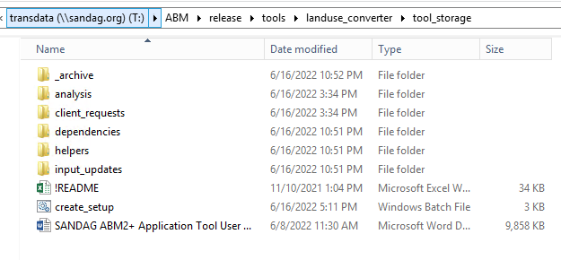
Figure 2: ABM2+ Application Tool Storage Directory

Table 1: Tool Storage Directory on SANDAG T: Drive
directory/File | Description
analysis | Report templates.
client_requests | Client update request file.
dependencies | Python dependencies to run the tool.
helpers | Scripts to update property files in case the no-build run used a different ABM2+ release. Script to initialize Emme folder for new scenarios.
input_updates | Files relevant for input updates to represent development project.
!README.xlsx | Template excel file to keep notes about the project and the scenarios.
create_setup.bat | Batch script to create project directory.
‘SANDAG ABM2+ Application Tool User Guide.docx’ | Copy of the user’s guide for the tool.

Setup Requirement
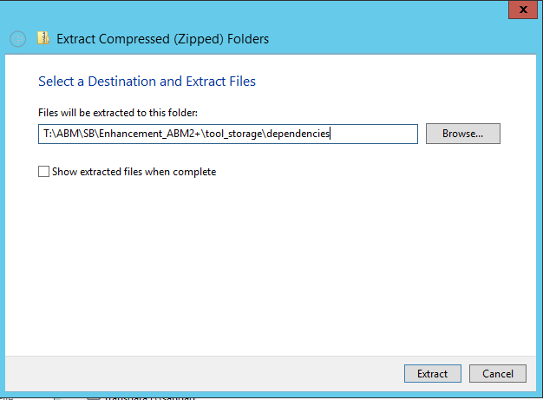
The tool requires some specific python packages. An environment has been setup which is portable and the tool runs from the directory where it is stored. Note that, only once, the user needs to create necessary dependencies using the steps below, if this has already been done and the miniforge directory already exists, skip.
- First, under the dependencies directory, extract the ‘miniforge.zip’ to the same folder (Figure 3). This extracted folder will be about 210MB.
Figure 3: Extract 'miniforge.zip'

- After unzipping, run the executable to install Mambaforge for windows ‘Mambaforge-4.10.3-6-Windows-x86_64.exe’
  - Add Mambaforge to the PATH environment variable when prompted as shown in Figure 4.
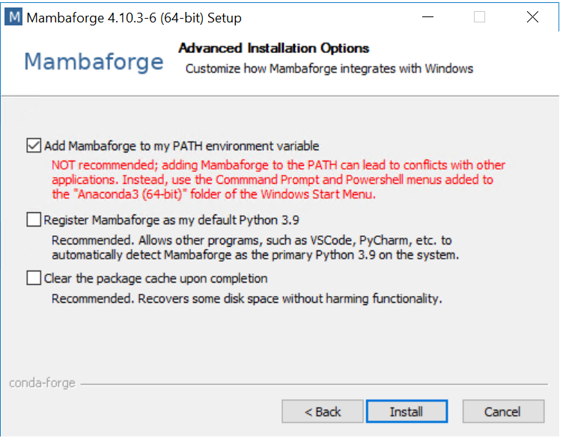
Figure 4: Mambaforge Installation
- Next, create the necessary python environments. Open the command prompt and run ‘setupEnvironments.bat’ script located in the dependencies folder as shown in Figure 5. This step may take a few minutes. Now the ‘miniforge’ folder will be around 6.5GB.
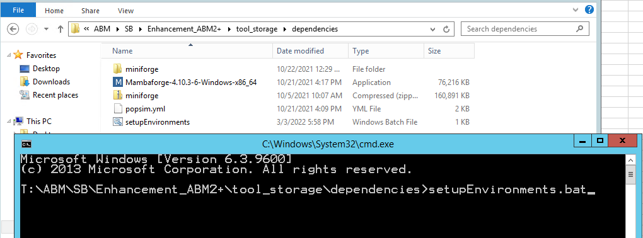
Figure 5: Setup Software Requirements From Batch File

Project Initiation and Setup
This chapter describes the first phase, project initiation and setup, of the ABM2+ application tool. The phase includes three tasks:
- Client request.
- Prepare cost and time estimate.
- Setup a project directory.
The following sections provide more details for these tasks.
- Client Request
This step initiates the SB workflow. A private engineering firm or a local government agency (the client) approaches SANDAG’s SB to help study impact of their proposed project using SANDAG’s travel model (ABM2+).
- Prepare Cost and Time Estimate
In this step, the SB reviews the request and prepares cost and time estimates to evaluate transportation impacts for the proposed project. The related files are stored under the folder “client_requests” (see the next step).
- Setup a Project Directory
Next, SANDAG staff shall follow the sequential steps below to create a project directory:
- Create a project folder on the drive\folder of the user’s choosing in which to create the setup used for the tool i.e. ‘C:\abm_runs\home_depot’; this directory will be referred to as the project directory.
- Copy the ‘create_setup.bat’ from the tool storage directory to the project directory.
- In the project directory, update the ‘create_setup.bat’ to have correct values for the following settings (see Figure 6):
  - ‘emme_version’ – set this to the same emme version used for the No-Build Scenario. It will be used to initialize the emme project folder.
  - ‘abm_release’ – set this to the abm release directory. Emme databanks are initialized here and the model setups will include all features of this release.
  - ‘tool_storage’ - path to the ABM2+ Application Tool. The tools from this directory are copied to the project directory and used in running the project. This will not need to be updated unless the location of the tool is changed.
  - ‘net_build_dir’ – path to the network folder directory to be copied for creating an ABM2+ workspace.
  - ‘net_build_years’ – space delimited list of network years needed for the project. Only these year subfolders will be copied over in order to conserve space.
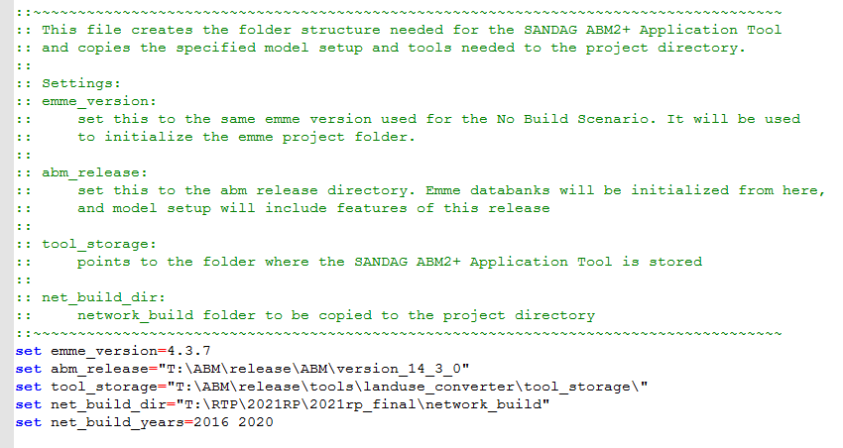
Figure 6: Create Setup batch Script – Update Paths
- Run the ‘create_setup.bat’ by opening a command prompt (type cmd in the windows explorer address bar and click enter), navigate to the project directory, type the batch file name, and hit enter as shown in Figure 7.
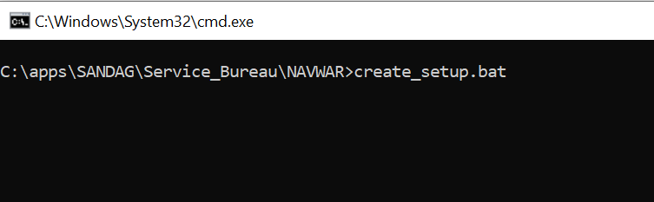
Figure 7: Create Folder Setup from Batch File
When finished running, the ‘create_setup.bat’ script will populate the project directory with a folder structure as shown in Figure 8 and Table 2.
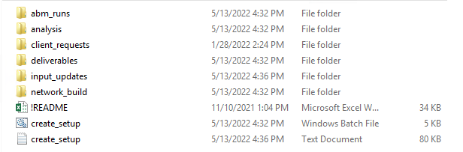
Figure 8: Project Directory Structure
Table 2: project Directory Description
Directory\File | sub directory | Description
abm_runs |  | No-build and build scenario runs
analysis |  | Summaries and reports requested by the client
client_requests |  | Data files received from the client
deliverables |  | Outputs delivered to the client
input_updates | 1_TAZ_split | Process to update appropriate input files in case of TAZ split
input_updates | 2_landuse_converter | Land use converter process
input_updates | 3_synthetic_population | PopulatonSim Repop process to update population
input_updates | 4_final_lu_update | Land use update process for updated population
input_updates | 5_hh_sampling | Household sampling process
input_updates | 6_reports | Analysis of results as requested by the client
network_build |  | Network data files, if TAZ split, prepared by SANDAG
!README.xlsx |  | Template excel file to keep notes about the project and the scenarios
create_setup.bat |  | Batch script to create project directory
create_setup.log |  | Log file for the create_setup.bat run

Run the Project
Once a project directory is setup (as described in Chapter 2.0), SANDAG staff shall use the project directory to perform all tasks related to the project. SANDAG staff shall use the following sequential tasks to define, add, and run the project using the SANDAG ABM2+:
- Define project with client.
- Update TAZ split related inputs.
- Update model inputs.
- Run models.
The following sections provide more details for these tasks.
- Define Project with Client
This task is performed under the directory ‘client_requests’ and involves communications with the client to define the project. SANDAG staff shall provide to the client the land use form (client_project_data.xlsx) available in the directory with the request to return the form filled with project specifications.
Figure 9 shows a template of the form (sheet ‘Project_Data’). The client shall complete this form with as much information about the project as possible. The first column “lu_code” lists all available land use (LU) codes with a brief description under column “LU Description”. The spreadsheet contains a sheet ‘Land Use Descriptions’ that includes a more detailed description of each LU code. The sheet ‘README’ provides information on rest of the columns in the form. Note that data entered in this form will be used to calculate number of employees for the project and if not specified, the tool will determine the employee information from SANDAG employment densities.
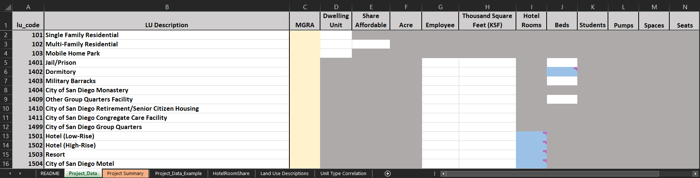
Figure 9: Client Input for ABM2+ Application Tool
To complete this form, the client shall, for all applicable LU types for the project, fill in the Master Geographic Reference Areas (MGRAs) of the project and enter information in applicable columns. If multiple MGRA’s use the same LU code, copy that LU code row, and add as new line so that each applicable MGRA has a line for that LU code. A few notes to keep in mind while completing the form:
Cells in grey are not applicable; data should not be entered in these cells
If inputting land use that contains them, cells in blue are mandatory, however their values are not used to calculate number of employees, but rather to provide land use intensity values for the MGRA land use file. If inputting data in such cells, data should also be input in other applicable cells.
For readability, rows without data may be deleted but it is not necessary
After entering data, check the sheet “Project Summary” to review project level totals by data type (columns in the form) and verify that the summary is consistent with the project specifications
- Update TAZ Split Related Inputs
This task is performed under the directory “network_build” and is required only if a TAZ split is appropriate for a given scenario. If TAZ split is not required, SANDAG staff should skip this task.
SANDAG staff performs this task using in-house tools and shall generate the following files:
- MGRA to TAZ crosswalk (“mgra_zone.csv”) under the directory “network_build\data”. The file shall have two columns: mgra, taz.
- Network files (highway, active transportation, and transit) under the directory “SPLIT_NETWORK_DIR" specified in master_batch.bat (see in Section Task 9:).
- Zone centroids (“tazcentroids_cvm.csv”) under the directory “SPLIT_NETWORK_DIR" specified in master_batch.bat. The file shall have five columns: taz, x_coord_spft, y_coord_spft, x_coord_albers, y_coord_albers.
- Zone to jurisdiction and CPA crosswalk (“zone_jur.csv”) under the directory “SPLIT_NETWORK_DIR” specified in the master_batch.bat.
- Update Model Inputs
This task is performed under the directory “input_updates”. After the project is defined by the client, the next step is to create the model run scenarios and update model inputs to reflect the project data. This step is automated and run using a batch file: ‘input_updates\master_batch.bat’.
The batch file runs the following seven steps:
- Create Baseline and/or Scenario – The option to create a baseline scenario (copy an existing Regional Plan (RP) run which will become the Baseline for model scenarios) and the option to create a scenario (copy the baseline run which becomes the scenario run after inputs are updated).
- TAZ split – updates geographies (TAZ) in model inputs (MGRA-based land use and synthetic population). This step is run only if a TAZ is split for a scenario. Note that this step in the batch file does not split TAZ or update network files, instead uses outputs of the TAZ split process to make other necessary updates to input files for new zone(s). The TAZ split process is performed by SANDAG staff using in-house tools (see Section Task 8:). This step is run under the directory ‘network build’.
- Land use converter – calculates new employment for the project and updates other land use attributes (hotels, enrollment, open space) in MGRA-based land use data. This step is run under the directory ‘02_landuse_converter’.
- PopulationSim repop – runs PopulationSim Repop mode to generate new population for the project. This step is only run if there are households in the project. This step is run under the directory ‘03_synthetic_population’.
- Land use data update – after a PopulationSim run, this updates the land use file to reflect the changes to the population and household income categories in the MGRA land use file. This step is only run if there are households in the project. This step is run under the directory ‘04_final_lu_update’.
- Household sampling – sets the sampling rate for households within buffer distances of the project. This step is run under the directory ‘05_hh_sampling’.
- Copy files to model directory – copies model inputs updated in previous steps to the build model directory.
To update model inputs, the user shall complete the following actions:
- Update settings in master batch file
- Run master batch file
- QA/QC outputs
These steps are explained in more detail below.

Update Settings in Master Batch File
The user shall review and update applicable settings in the master batch file (‘input_updates\master_batch.bat’). The settings are categorized as required and optional. Required settings need user’s input but optional settings can be kept to default values.

Global Settings
Global settings are available at the top of the master batch file, see Figure 10 and Table 3. These settings control execution of the six steps described above. By default, the batch file runs all steps. The user can set the configuration to not run a particular step by setting the corresponding setting (flag) to NO. This functionality is useful in troubleshooting a particular step or re-running the batch file from the step where it crashed the last time.
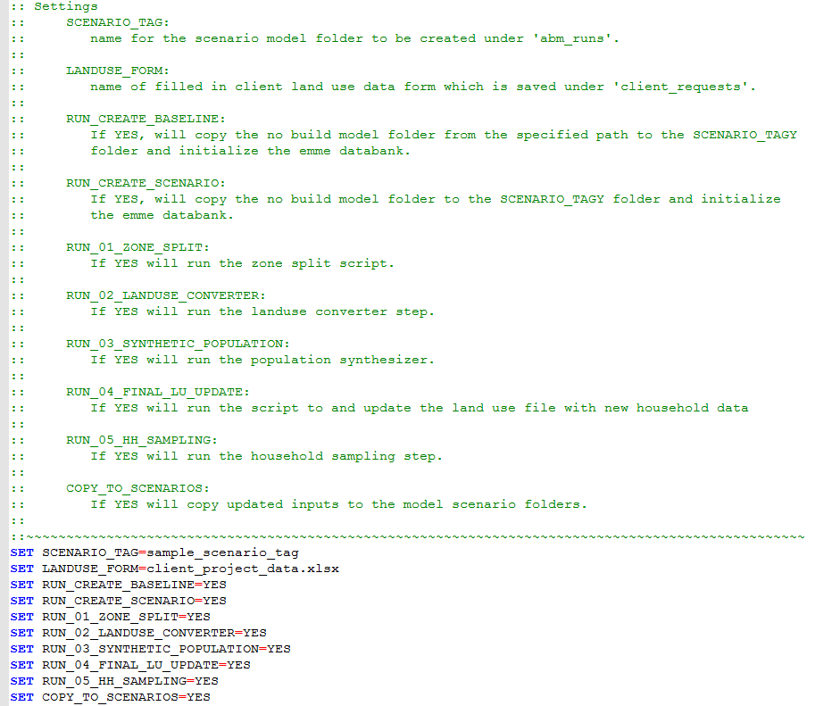
Figure 10: Global Settings

Table 3: Global Settings Description
Setting | Type | Default Value | Description
REQUIRED
SCENARIO_TAG | String | Sample_scenario_name | Tag for the baseline and scenario to be created under abm_runs. The scenario year will automatically be appended to the end of the name. i.e. if SCENARIO_TAG is set to ‘Home Depot’ and it is a 2016 model, the folder ‘Home_Depot_2016’ will be created under ‘abm_runs’.
LANDUSE_FORM | String | client_project_data.xlsx | Name of the client input land use form under ‘client_requests’.
OPTIONAL
RUN_CREATE_BASELINE | YES/ NO | YES | Runs (YES) or skips (NO) copying the baseline scenario as no_build_{SCENARIO_YEAR} and initializing the Emme project folder.
RUN_CREATE_SCENARIO | YES/ NO | YES | Runs (YES) or skips (NO) copying the no-build scenario as the scenario name and initializing the Emme project folder.
RUN_01_TAZ_SPLIT | YES/ NO | YES | Runs (YES) or skips (NO) the process to update inputs and the user expression calculator (UEC) in the case of a TAZ split. If there is no TAZ split this step will not update any files.
RUN_02_LANDUSE_CONVERTER | YES/ NO | YES | Runs (YES) or skips (NO) the process to convert land use data from client format to model input format.
RUN_03_SYNTHETIC_POPULATION | YES/ NO | YES | Runs (YES) or skips (NO) updating synthetic population. If not a housing development project, this step is skipped automatically regardless of setting. This setting is also applied to the next step (04_final_lu_update) of updating land use data.
RUN_04_FINAL_LU_UPDATES | YES/NO | YES | Runs (YES) or skips (NO) the process to update the land use file with new household/population data.
RUN_05_HH_SAMPLING | YES/ NO | YES | Runs (YES) or skips (NO) the process to add sampling rates to households based on buffer distances of the project.
COPY_TO_SCENARIOS | YES/ NO | YES | Runs (YES) or skips (NO) copy of the updated model inputs to the build and no-build model folder.

Create Baseline Settings
Use the global setting ‘RUN_CREATE_BASELINE’ set to ‘YES’ to create a new scenario. Set ‘no_build_model_dir’ to the directory from which to copy the scenario as shown in Figure 11. This may be any model run the user desires. If the user setting “VISION” is set to “YES”, the airport mode choice UECs, employee parking ratios, and airport transit connection mgra’s which include the airport ‘people mover’ are used instead of the existing settings in the baseline run. This only happens according to the model year, for example, if the model run is pre-2030 and “VISION” is set equal to “YES” there is still not a people mover implemented since it is not planned for construction until 2030. If the baseline model folder already exists, the user will be prompted to either overwrite or keep the existing folder.
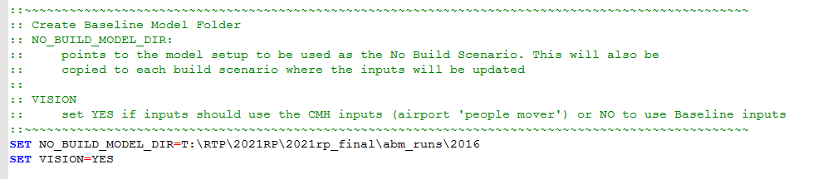
Figure 11: Run Create Baseline Setting

Create Scenario Settings
If a new scenario is desired, set ‘RUN_CREATE_SCENARIO’ to ‘YES’. A baseline scenario must exists in which to copy to create the scenario. The ‘SCENARIO_TAG’ setting in global settings tells this step which baseline to use. If this folder already exists, the user will be prompted to either overwrite or keep the existing folder.

TAZ Split Settings
The next set of settings are related to the TAZ split step, see Figure 12, and are applicable only if RUN_01_TAZ_SPLIT is set to YES under global settings.
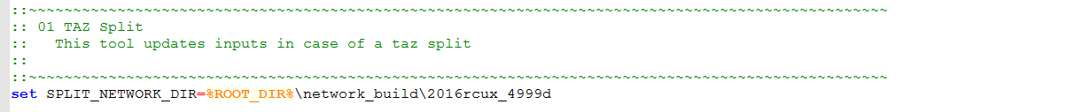
Figure 12: TAZ Split Settings
The user shall update “SPLIT_NETWORK_DIR” with the appropriate path where the TAZ split process was performed for the project. Note that the assumption is that the TAZ split process is performed inside the directory “network_build”, therefore, the user shall provide the path to a network directory inside it. This directory shall contain updated network files and zone centroid file as listed under Section Task 8:. Also, a new crosswalk between MGRA and TAZ (“mgra_zone.csv”) shall be available under “network_build\data”.
The TAZ split step in the batch file uses a python script to update relevant inputs and UECs for the new TAZ(s) as shown in Table 4. These files are saved in the “1_taz_split\outputs” directory so they can later be copied to the build directory during the last step. New network files (highway, transit, and active transportation) and the zone centroid file from the network build folder are also copied to the “input_updates\1_taz_split\outputs” directory in place to be copied to the build directory in the last step.
Note that if the user set RUN_01_TAZ_SPLIT to YES but the MGRA to TAZ crosswalk (“network_build\data\mgra_zone.csv”) does not have the new zone(s), the TAZ split step will assume that there is no zone split and will skip the TAZ split step. In such case, the tool will log a WARNING indicating TAZ split setting set to YES but not found in the crosswalk.

Table 4: TAZ Split Settings Description
File | UPDATE
conf\sandag_abm.properties | Update the setting “zone.count” with new zone count.
conf\cvm.properties | Update the setting “EndZone” with new zone count.
uec\CrossBorderDestinationChoiceSoaAlternatives{year}.csv | Update to include new zones. Add alternatives for new zone(s) using the same values that exist for the original zone that is split. Here, year = 2020,2025,2035,2050.
uec\SoaTazDistAlts.csv | Update to add alternatives for new zones.
uec\TourDcSoaDistanceAlts.csv | Update to add alternatives for new zones.
input\zone.term | Update only if the split TAZ has a zone terminal time. New TAZ is added with the same terminal time as the split TAZ.

Land Use Converter Settings
After the TAZ split step, the batch file contains settings for the land use converter tool. Figure 13 shows theses settings as available in the master batch file and Table 5 describes them in more detail.
The land use converter tool takes the client land use form and converts it into a format expected in the model. The tool updates the MGRA land use file that is input to the model by overriding or adding land use for the new project.
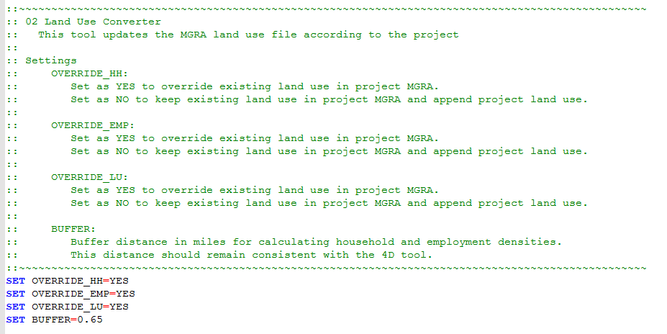
Figure 13: Land Use Converter Settings
Table 5: Land Use Converter Settings Description
Setting | Type | Default Value | Description
REQUIRED
OVERRIDE_HH | YES/NO | YES | Indicates whether new households should override (YES) or append (NO) the existing households in the project MGRA(s).
OVERRIDE_EMP | YES/NO | YES | Indicates whether new employment should override (YES) or append (NO) the existing employment in the project MGRA(s).
OVERRIDE_LU | YES/NO | YES | Indicates whether new land use data should override (YES) or append (NO) the existing land use data in the project MGRA(s). Here, the land use data include hotels, open space acres, and school enrollment.
OPTIONAL
BUFFER | Float | 0.65 | Buffer distance in miles for selecting households and employment for density.

Synthetic Population Settings
The next set of settings are related to the step which, if the project contains housing development, updates synthetic population files to reflect population for the project. If not a housing development project, the batch file skips this step. Figure 14 shows theses settings as available in the master batch file and Table 6 describes them in more detail.
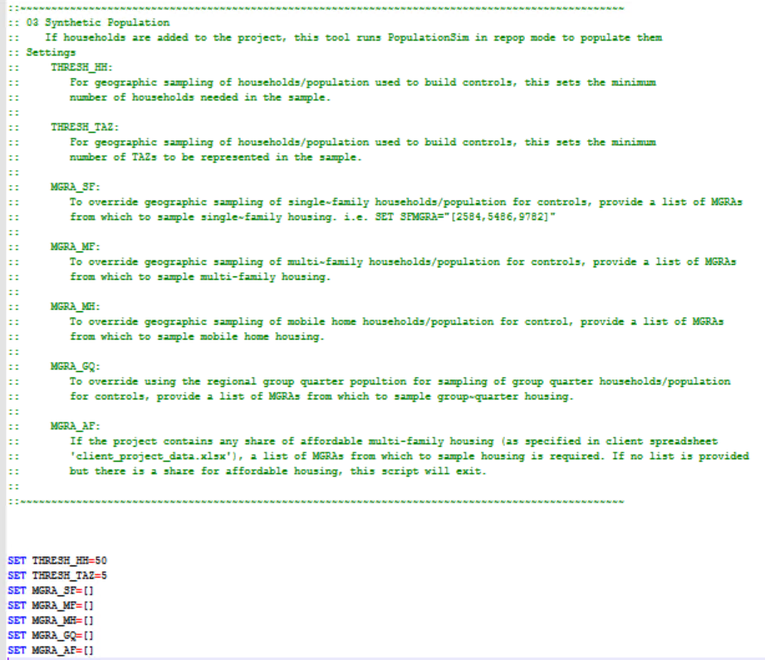
Figure 14: Synthetic Population Settings

Table 6: Synthetic Population Settings Description
Setting | Type | Default Value | Description
OPTIONAL
THRESH_HH | Integer | 50 | Minimum number of households needed to develop controls for a given household type. Applicable only when corresponding MGRA list is empty.
THRESH_TAZ | Integer | 5 | Minimum number of TAZs needed to develop controls for a given household type. Applicable only when corresponding MGRA list is empty.
MGRA_SF | List | [] | MGRA(s) from which to develop controls for Single-Family housing population. If empty ([]), default geographic search is used.
MGRA_MF | List | [] | MGRA(s) from which to develop controls for Multi-Family housing population. If empty ([]), default geographic search is used.
MGRA_MH | List | [] | MGRA(s) from which to develop controls for Mobile Homes population. If empty ([]), default geographic search is used.
MGRA_GQ | List | [] | MGRA(s) from which to develop controls for Group Quarters population. If empty, default geographic search is used.
MGRA_AF | List | [] | MGRAs from which to develop controls for Affordable Housing population. Presently, all affordable housing is assumed to be Multi-Family. If an affordable housing share is specified this list is REQUIRED.

This step runs PopulationSim with the ‘Repop’ feature to update population records only for the project MGRA(s). The population records in other MGRA(s) are kept the same as the no-build scenario. A ‘Repop’ run samples new records from the existing population (no-build) to match marginal distributions (controls) developed using population records from either user specified MGRAs or a geographic search. The user can specify a list of MGRAs by housing type to use in developing marginal controls. If a list is empty, by default, the tool builds controls using a geographic search approach that starts from each project MGRA and uses households in MGRAs that fall within a specific distance buffer and with at-least 85% households of the given type. The search starts with a half-mile buffer and is extended by one quarter mile until two thresholds of minimum number of households (THRESH_HH) and minimum number of MGRAs (THRESH_TAZ) are met.

Household Sampling Settings
After the synthetic population update, the batch file contains settings for the household sampling step which assigns a household sample rate that vary by distance of the corresponding MGRA from the project MGRA(s). Figure 15 shows theses settings as available in the master batch file and Table 7 describes them in more detail.
In the present setup, the sample rate is set to one for each geographic boundary. The tool allows the user to use sample rates which decrease with increased distance away from the project. Specifically, households in and around the project MGRA(s) can be oversampled to reduce simulation variability in model results while households far away from the project are under sampled to offset increase in runtime due to oversampling by compromising a little on stability of results for these households. The tool allows user to specify three different household sampling rates for MGRAs by distance from the project location. It is recommended to not use this functionality until further testing provides better insights on how over and under sampling can affect vehicle assignments.
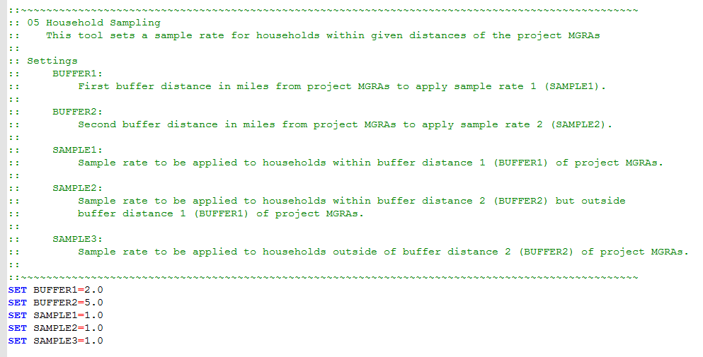
Figure 15: Household Sampling Settings

Table 7: Household Sampling Settings Description
Setting | Type | Default Value | Description
OPTIONAL
BUFFER1 | Float | 2 | Distance (miles) from project MGRA(s) to assign first household sample rate (SAMPLE1).
BUFFER2 | Float | 5 | Distance (miles) from project MGRA(s) to assign second household sample rate (SAMPLE2). This value must be greater than BUFFER1.
SAMPLE1 | Float | 1 | Household sample rate assigned to MGRAs that are within BUFFER1. A value of 0.5 means 50% and a value of 4 means 400%.
SAMPLE2 | Float | 1 | Household sample rate assigned to MGRAs that are outside BUFFER1 but inside BUFFER2. A value of 0.5 means 50% and a value of 2 means 200%.
SAMPLE3 | Float | 1 | Household sample rate assigned to MGRAs that are outside BUFFER2. A value of 0.5 means 50% and a value of 1 means 100%.

Run Master Batch File
Once configured all the appropriate settings (see the previous section), the user shall execute the master batch file from the command line as shown in Figure 16.
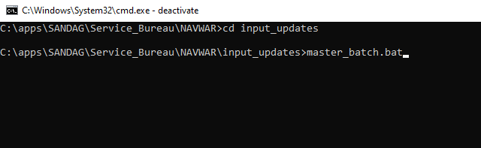
Figure 16: Run Master Batch File
After finished, the batch file produces a log file ‘tool.log’ recording a higher-level logging of each step run in the batch file. The user should check this log file to make sure all steps finished successfully.
If a step did not finish correctly, the batch file will report an error and exit. If that happens, the user should first check the tool.log file and then review the detailed log file of the problematic step to troubleshoot the error. Table 8 presents the step specific log files generated by the batch file.
Table 8: Log File Locations
Step | Log File Location
master_batch.bat | “input_updates\tool.log”
01_taz_split | “input_updates\01_taz_split\01_taz_split.log”
02_landuse_converter | “input_updates\02_landuse_converter\02_landuse_converter.log”
03_synthetic_population | “input_updates\03_synthetic_population\setup\logs”
04_final_lu_update | “input_updates\04_final_lu_update\04_final_lu_update.log”
05_hh_sampling | “input_updates\05_hh_sampling\05_hh_sampling.log”

Quality Assurance/Quality Control Outputs
In addition to updating necessary model inputs, the master batch file generates summaries and\or maps to help the user perform a quick quality assurance and quality control (QA/QC) of the updates before using them in a model run. The following sections describe the QA/QC outputs that are produced by two main steps in the batch file – the land use converter and household sampling.

Land Use Converter
The land use converter step generates outputs under “input_updates\2_landuse_converter\outputs”. For QA/QC of the updates, this step produces a HTML file called “landuse_updates.html” that presents a tabular and spatial summary of the changes in the MGRA land use file due to addition of the project.
The HTML file contains two tabs:
- First tab (Land Use Data) shows three tables: initial land use, final land use, and change in land use as shown in Figure 17. These tabular summaries are useful to verify project level changes in the land use file.
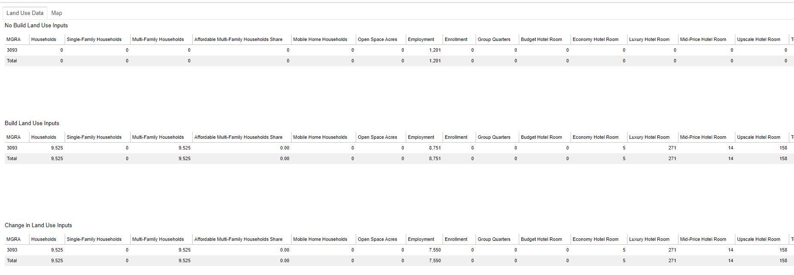
Figure 17: landuse converter – HTML File (Land Use Data Tab)
- The second tab (Map) shows a spatial map of the project changes at MGRA level, see Figure 18. The user may hover the mouse over the layer icon in the top right corner and select single or multiple layers to draw. Note that only project specific layers are available. For example, the layers ‘households’ and ‘household density’ are available only if the project involves a housing development.

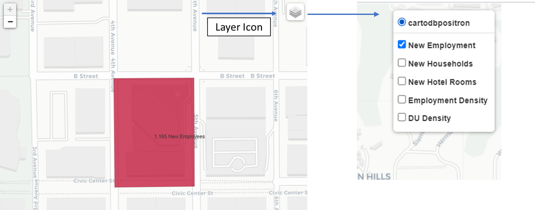
Figure 18: land use converter – HTML FIle (Map TAB)

Household Sampling
The household sampling step generates outputs under ‘input_updates\05_hh_sampling\outputs’. For QA/QC of the updates, the step produces a spatial map called ‘sample_rate_map.html’. As shown in Figure 19, the map displays geographic placement of each sample rate.
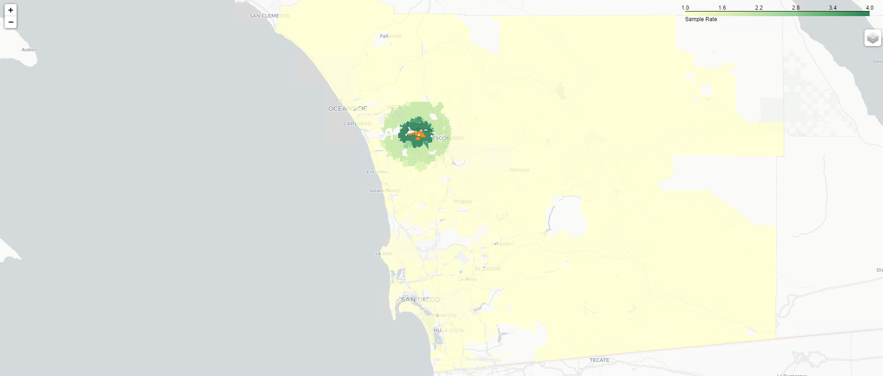
Figure 19: Household Sampling - Sample Rate Map
The step also generates a csv file (‘sampled_households_check.csv’) summarizing the household totals before and after the sampling and the number of records of households. Figure 20 presents the format. This file is useful in verifying that the sample rates were applied correctly; number of records should reflect total number of households multiplied by the sample rate, and number of households should match the input number of households.
Figure 20: Household Sampling - QA/QC Spreadsheet
- Run Models
This task is performed under the directory “abm_runs”.
At this point, the user has prepared the no-build and build scenarios and the next step is to run them. Given that the build scenario will be using household sampling, the user should also run the no-build scenario with the same household sampling. The process already prepares the no-build scenario setup with household sampling incorporated in population files so no additional actions are required.
The user should run the models (no-build and build) with the standard procedure for running the ABM2+. The model setups would have the main model properties file (sandag_abm.properties) configured as necessary to run the model, however, before starting a run, the user should make sure that the Emme graphical user interface (GUI) has correct steps set to do a full model run. If a select link is desired, the user needs to enter the information as needed in the GUI.
Note that the new activity-based model (ABM2+) setup includes a shadow pricing enhancement to build shadow pricing files automatically as part of a model run. In the Emme GUI, if desired, the user can choose to not run shadow pricing by selecting ‘skip shadow pricing’. If skipped, as before, the model will use the input shadow prices files for AB model (CT-RAMP) runs.

Evaluation and Reporting
After the model runs finish successfully, SANDAG staff shall evaluate results, generate necessary reports, and deliver to client. This is the last phase of the SB process and includes three tasks:
- Run reports
- Deliver to client
- Invoice and closeout
The following sections provide more details for these tasks.
- Run Reports
This task is performed under the directory “analysis”.
Once the model runs have successfully completed, SANDAG staff shall start their in-house process to load model outputs under “report” into the SANDAG SQL database. Next, the staff shall generate the Power BI reports for mode choice and vehicle miles traveled (VMT) summaries under the directory “analysis”.
- Deliver To Client
This task is performed under the directory “deliverables”.
This is the last technical task in the process, where the user shall forward the requested outputs from the previous step to the client for their analysis. If there are no further queries from the client, this step will conclude the SB process.
- Invoice and Closeout
Following approval of the model outputs by the client, the SB shall invoice the client and closeout the subarea analysis process. Closeout will also include archiving datasets and workspaces. If there are no further queries from the client, this step concludes the SB process.

Example Project 1 – Mission Valley Home Depot
This chapter provides instructions on how each task of the phase “Run the Project” should be performed for the example project 1, Mission Valley Home Depot project. Note that the other two phases (“Project Initiation and Setup” and “Evaluation and Reporting”) are self-explanatory and, therefore, omitted here.
After receiving the client request and preparing cost and time estimate, the first step is to create a project directory. Follow the instructions under Chapter 3. This chapter describes the first phase, project initiation and setup, of the ABM2+ application tool. The phase includes three tasks:
- Client request.
- Prepare cost and time estimate.
- Setup a project directory.
Use the setup a project directory to create a project directory for the Mission Valley Home Depot project. Use this directory to perform the steps as described below. The following sections provide more details for subsequent tasks.
- Define Project with Client
This project redevelops a portion of the existing Scottish Rite Center into a Home Depot store and removes all other remaining land use assumptions. The project MGRA is 6190 with project details as shown in Table 9.
Table 9: Land Use Data - HOme Depot Example
Land Use Code | Input
5003 (Neighborhood Commercial) | 127,000 square feet
7206 (Convention Center) | 40,000 square feet
For this project, only two rows are necessary in the ‘client_landuse_data.xlsx” and will look as shown in Figure 21. This file is then saved as ‘client_landuse_data_home_depot.xlsx’.
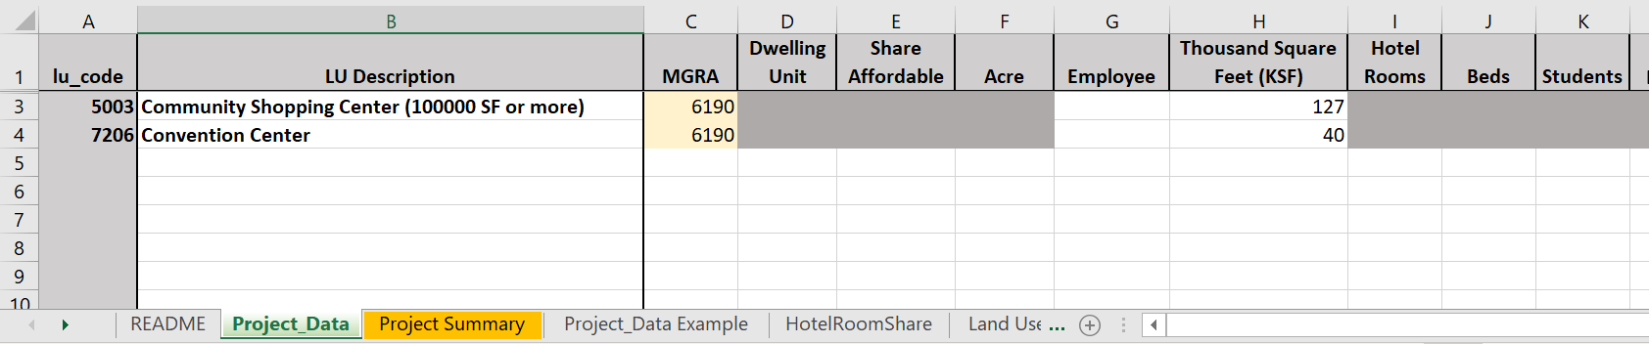
Figure 21: Client Land Use Form – Home Depot
The sheet “Project Summary” will summarize all the user inputs. This is the first check for the client to see that the project is coded as expected. Since only thousand square feet (KSF) is provided, the only summary with a value is for KSF as shown in Figure 22.
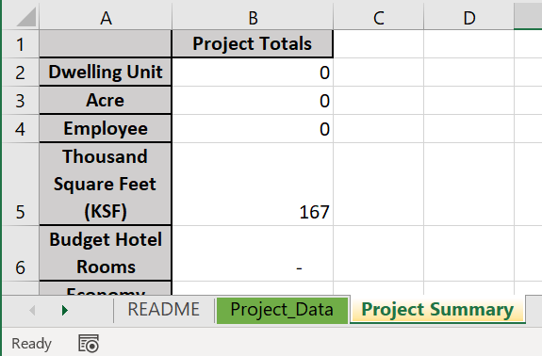
Figure 22: Project Summary – Home Depot
- Update TAZ Split Related Inputs
This project does not require a TAZ split, so this step is skipped.
- Update Model Inputs
This task updates the settings in the master batch file, runs the master batch file, and reviews the quality of the data outputs.

Update Settings in Master Batch File
Next, the ‘master_batch.bat’ file under ‘input_updates’ needs to be configured for the project.

Global Settings
As shown in Figure 23, add the correct land use data file name: ‘client_project_data_home_depot.xlsx’ which is saved under the directory ‘client_requests’. For a new set up, run all the steps as shown in Figure 23.
Note that turning some steps off (NO) could be helpful if debugging or restarting steps after they have crashed.

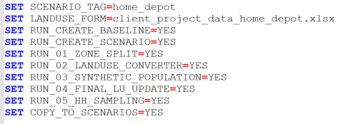
Figure 23: Global Settings - Home Depot

Create Baseline
Since this is the first time the project is being run, a baseline scenario needs to be created. Set the ‘no_build_model_dir’ path to the directory from which to copy the baseline scenario as shown in Figure 24. The year of this scenario should match the year passed in the global setting “SCENARIO_YEAR”. This folder will appear under ‘abm_runs\no_build_2016’ since it is the baseline model for the scenario year 2016

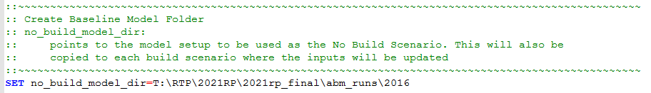
Figure 24: Create Baseline Settings

Create Scenario
The global setting ‘RUN_CREATE_BASELINE’ is set to “YES” which will prompt the tool to copy the rtp scenario as the scenario and name it “no_build_home_depot_2016” according to the user inputs. Similarly the global setting ‘RUN_CREATE_SCENARIO’ is set to “YES” which will prompt the tool to copy the newly created baseline as the new scenario “home_depot_2016”

TAZ Split Settings
The project did not require a TAZ split. The same is specified in the global settings, Figure 23, as “RUN_01_ZONE_SPLIT” is set to “NO” to skip the process. So, no need to update TAZ split settings.

Land Use Converter Settings
Since this project is to override the existing land use, set ‘OVERRIDE_HH’, ‘OVERRIDE_EMP’, and ‘OVERRIDE_LU’ to ‘YES’ as shown in Figure 25.
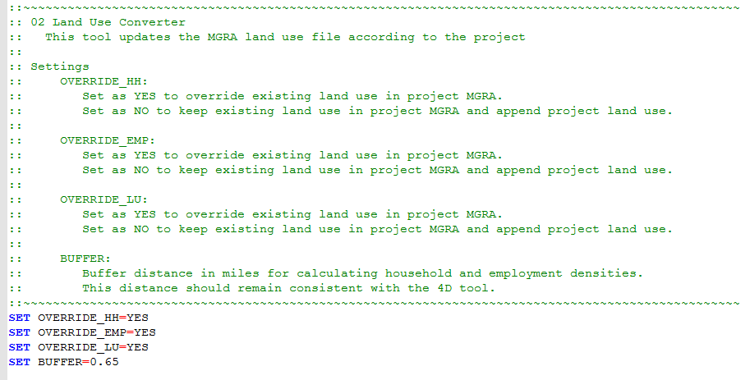
Figure 25: Land Use Converter Settings - Home Depot

Synthetic Population Settings
Because there are no households in this project, the 03_synthetic_households will automatically be skipped and no adjustments to these settings in the master batch file are needed.

Final Land Use Updates
This step will check if the land use file needs to be updated based on the project specifications.

Household Sampling Settings
No changes are needed in the household sampling settings as defaults settings can be used. As shown in Figure 26, by default, the buffer area 1 is 2 miles, buffer area 2 is 5 miles and the three sampling rates are 4.0, 2.0 and 1.
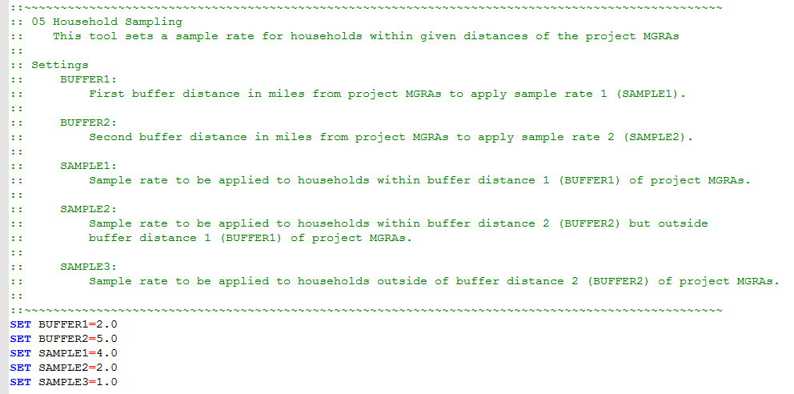
Figure 26: Household Sampling Settings - Home Depot

Run Master Batch File
After configuring the batch file, the application tool shall be run from the command line as shown in Figure 27.
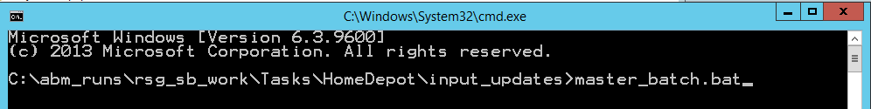
Figure 27: Run Application Tool - Home Depot
The application tool takes approximately 35 minutes to finish. Table 10 provides the breakdown of the runtime by step.
Table 10: Master Batch File Runtime by Step – Home Depot
Step | Runtime
Land use convert tool | 9 minutes
Final Land Use Update | 4 minutes
Household sampling | 14 minutes
Total | 27 minutes

Quality Assurance/Quality Control Outputs
Check the ‘tool.log’ file under the ‘input_updates’ folder to see the sequence of steps executed by the master_batch.bat file.

Land Use Converter
Under ‘02_landuse_converter\outputs’, the first tab in the ‘landuse_update.html’ file shows the original land use data from the model no-build scenario in the first table as shown in Figure 28. This table is very important to review to confirm what is in the no-build scenario and what has been overridden. The table shows there are 6 acres of open space park and 339 enrolled students in the project MGRA before the project exists (‘No-Build Land Use Inputs’). Since the land use is overridden, the next table ‘Build Land Use Inputs’ shows they no longer exist in the build scenario. Also, the project land use is added in the form of 298 new employment because of the project KSF. The third table ‘Change in Land Use Inputs’ shows the change in each land use category from build to no-build scenario.
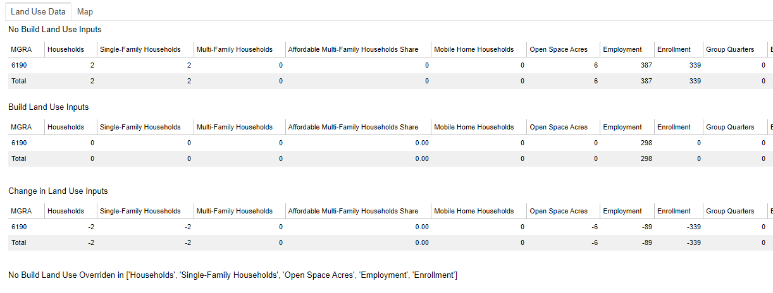
Figure 28: Land Use Data Tables - Home Depot

If the land use changes are as expected, another check can be done on the next tab ‘map’ in the ‘landuse_update.html’ file. As shown in Figure 29, the spatial map contains three layers showing the new project employment, the employment density of MGRAs where the density has changed, and the MGRAs where household or dwelling unit density has changed. This is to ensure that the project is in the expected location and the changes to densities are in close proximity to the project.
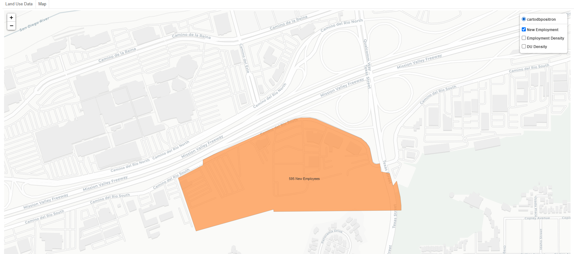
Figure 29: Land Use Update Spatial Map - Home Depot

Household Sampling
The household sampling step also includes a spatial map for the user to verify the location of the sampling rates. This map is saved under ‘05_hh_sampling\outputs\samplerate_map.html’. The project MGRAs will be drawn in orange while the respective sample rate for all other MGRAs will be drawn according to their specification. Figure 30 shows the spatial distribution of the sample rates used for the Home Depot project. Figure 31 shows the results in the “sampled_households_check.csv” file.
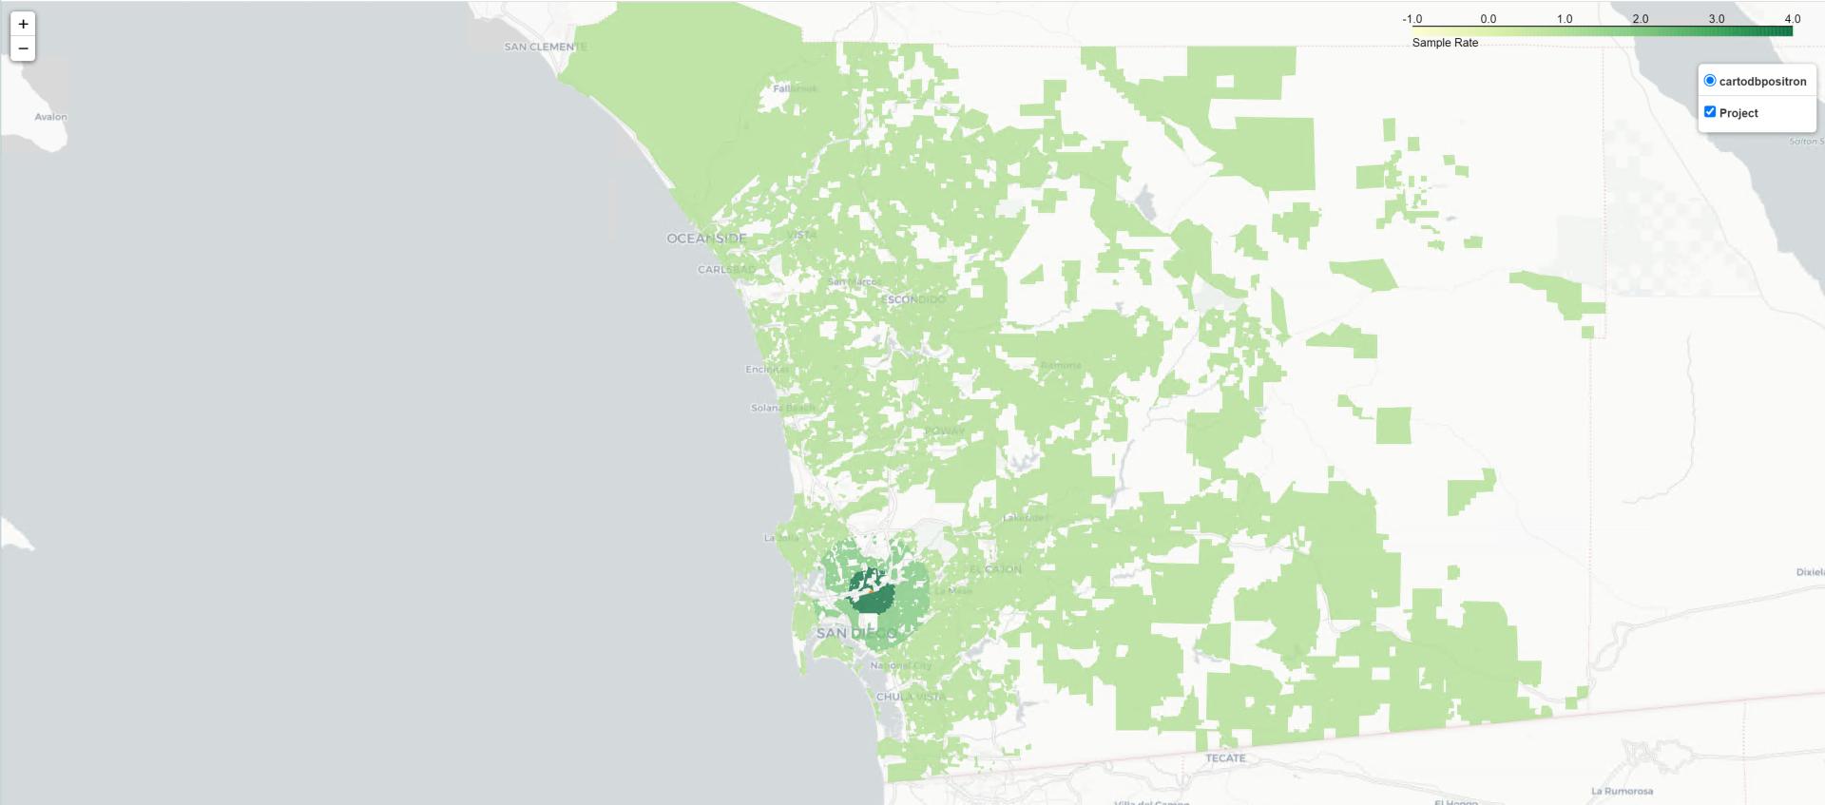
Figure 30: Sample Rate Map - Home Depot
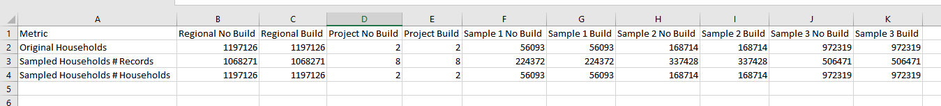
Figure 31: Home Depot Household Sampling Check
- Run Models
At this point, all inputs are updated, and the two scenarios are setup as needed. Next, the user should run the two scenarios located under “abm_runs” with the standard procedure for running the ABM. The model setups would have the main model properties file (sandag_abm.properties) configured as necessary to run the model, however, before starting a run, the user should make sure that the Emme GUI has correct steps set to do a full model run. If a select link is desired, the user needs to enter the information as needed in the GUI.

Example Project 2 – Naval Information Warfare Systems Command High-Density Development
This chapter provides instructions on how each task of the phase “Run the Project” should be performed for the example project 2, the Naval Information Warfare Systems Command (NAVWAR) high-density development with transit center. Note that the other two phases (“Project Initiation and Setup” and “Evaluation and Reporting”) are self-explanatory and, therefore, omitted here.
After receiving the client request and preparing cost and time estimate, the first step is to create a project directory. Follow the instructions under Chapter 3. This chapter describes the first phase, project initiation and setup, of the ABM2+ application tool. The phase includes three tasks:
- Client request.
- Prepare cost and time estimate.
- Setup a project directory.
Use the setup a project directory to create a project directory for the NAVWAR project. Use this directory to perform the steps as described below. The following sections provide more details for subsequent tasks.
- Define Project with Client
This project redevelops the whole existing NAVWAR facility into a high density mixed-use development. The project MGRA is 3093 with project details as shown in Table 11.
Table 11: Land Use Data – NAVWAR
Land Use Code | Input
102 (Multi-Family Residential) | 10,000 units
1502 (High Rise Hotel) | 450 Rooms
4111 (Transit Center) | 25 Employees
5003 (Community Shopping Center) | 250,000 Square Feet
6001 (High Rise Office) | 1,350,000 Square Feet
6003 (Government Office) | 420 Employees

The client land use form is filled out accordingly and shown in Figure 32.

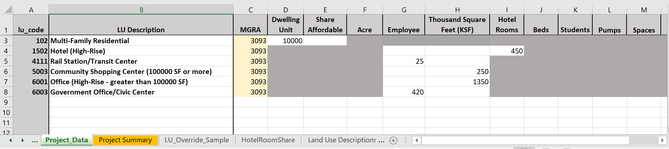
Figure 32: Client Land Use Form – NAVWAR

The sheet “Project Summary” summarizes the inputs, see Figure 33. This is the first check for the client to see that the project is coded as expected. The segmentation of hotel room type for the 450 hotel rooms in the project is calculated from a set distribution which is saved in the ‘HotelRoomShare’ sheet of this spreadsheet (Figure 34). If this information available for the project, the client can edit the distribution.
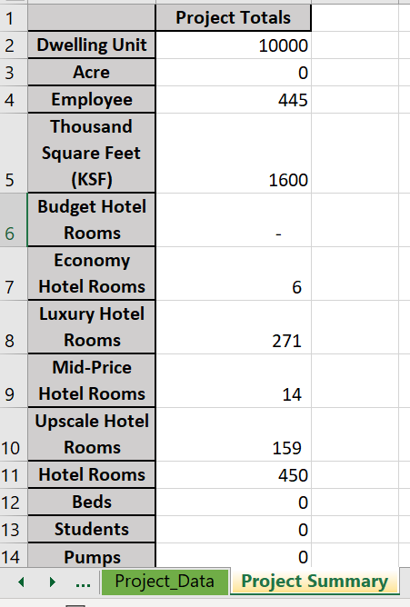
Figure 33: Project Summary – NAVWAR
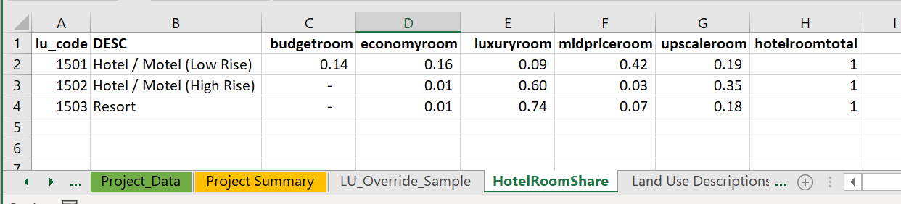
Figure 34: Hotel Room Shares
- Update TAZ Split Related Inputs
This project does not require a TAZ split, so this step is skipped.

- Update Model Inputs
This task updates the settings in the master batch file, runs the master batch file, and reviews the quality of the data outputs.

Update Settings in Master Batch File
Next, the ‘master_batch.bat’ file under ‘input_updates’ needs to be configured for the project.

Global Settings
As shown in Figure 35, add the correct land use data file name: ‘project_data_NAVWAR.xlsx’ which is saved under the directory ‘client_requests’. For a new set up, run all the steps as shown in Figure 35.
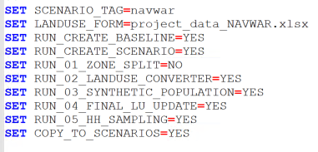
Figure 35: Global Settings - NAVWAR
Note that turning some steps off (NO) is helpful if debugging or restarting steps after they have crashed.

TAZ Split Settings
The project did not require a TAZ split. The same is specified in the global settings, Figure 35, as “RUN_01_ZONE_SPLIT” is set to “NO” to skip the process. So, no need to update TAZ split settings.

Land Use Converter Settings
Since this project is to override the existing land use, set OVERRIDE_HH’, ‘OVERRIDE_EMP’, and ‘OVERRIDE_LU’ to ‘YES’ as shown in Figure 36.
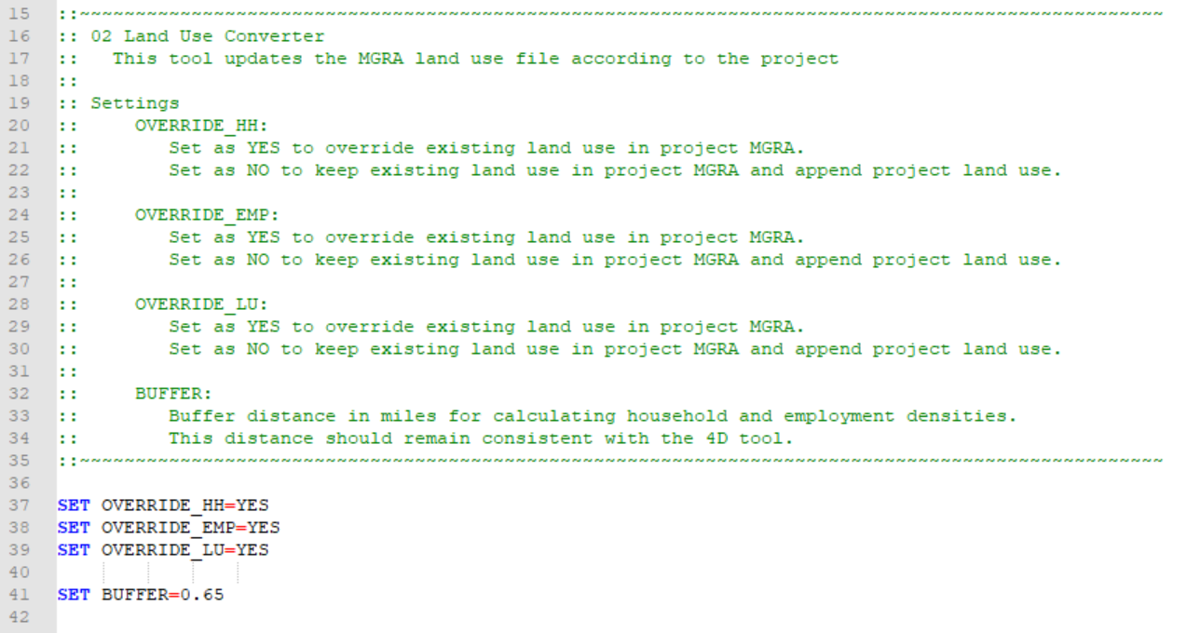
Figure 36: Land Use Converter Settings - NAVWAR

Synthetic Population Settings
There are 10,000 multi-family dwelling units in this project, therefore, PopulationSim will need to be run. No changes are needed in the synthetic population settings as default settings can be used, see Figure 37.
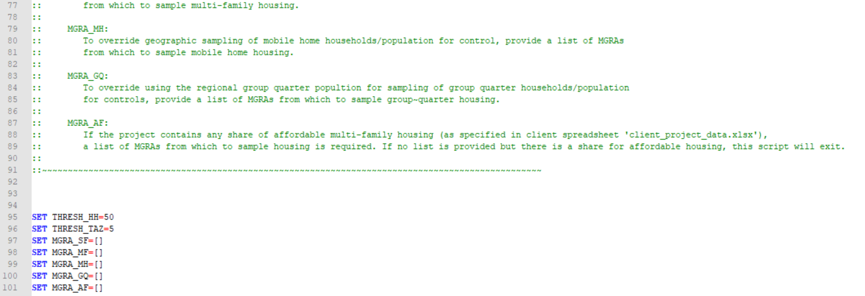
Figure 37: PopulationSim Settings - NAVWAR

Household Sampling Settings
No changes are needed in the household sampling settings as default settings can be used. As shown in Figure 38, by default, the buffer area 1 is 2 miles, buffer area 2 is 5 miles, and the three sampling rates are 4.0, 2.0 and 1.
Figure 38: Household Sampling Settings – NAVWAR

Run Master Batch
After configuring the batch file, the application tool shall be run from the command line as shown in Figure 39.
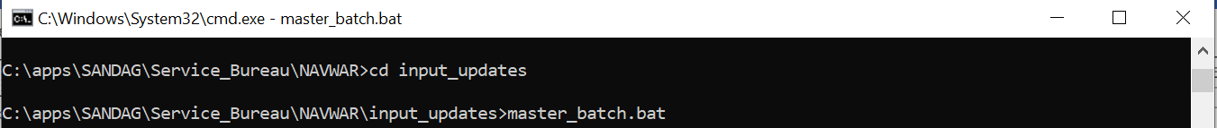
Figure 39: Run Application Tool - NAVWAR
The application tool takes approximately 36 minutes to finish. Table 12 provides the breakdown of the runtime by step.
Table 12: Master Batch File Runtime by Step – NAVWAR
Step | Runtime
Land use convert tool | 8 minutes
Populationsim repop | 6 minutes
Update land use data | 0.1 minutes
Household sampling | 22 minutes
Total | 36 minutes

Quality Assurance/Quality Control Outputs
Check the ‘tool.log’ file under the directory ‘input_updates’ to see the sequence of steps executed by the master_batch.bat file (Figure 40).
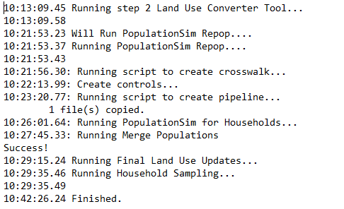
Figure 40: Input Update Log File – NAVWAR

Land Use Converter
Under ‘02_landuse_converter\outputs’, the first tab in the ‘landuse_update.html’ file shows land use data before (no-build) and after (build) updates as shown in Figure 41. This table is very important to review to confirm what is in the no-build scenario and what has been overridden.
Figure 41: Land Use Data Tables – NAVWAR
If the land use changes in the tables are as expected, another check can be done on the next tab ‘map’ in the ‘landuse_update.html’ file. As shown Figure 42, the spatial map has five layers showing the new project employment, the employment density of MGRAs where the density has changed, the project households, the MGRAs where the household or dwelling unit density has changed, and the total hotel rooms (Figure 42). This is to ensure the project is in the expected location and the changes to densities are located in close proximity to the project.
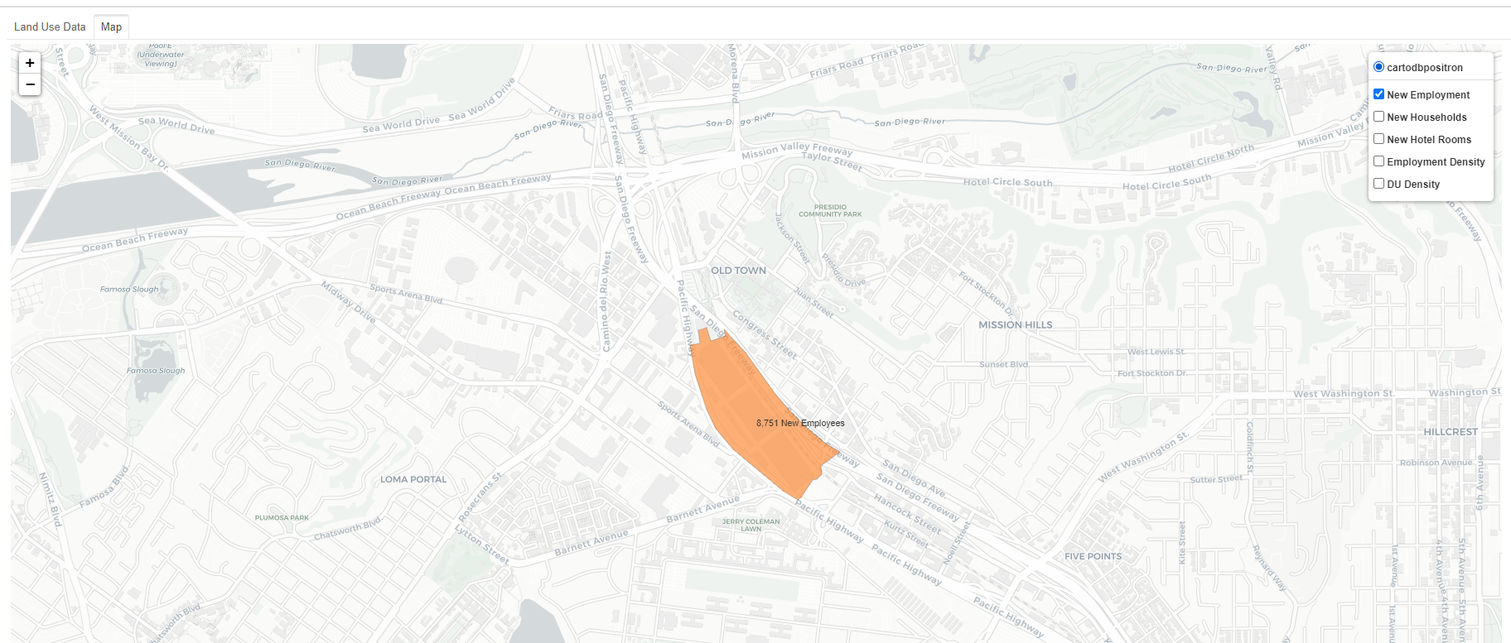
Figure 42: Land Use Update Spatial Map – NAVWAR

Household Sampling
The household sampling step also includes a spatial map for the user to verify the location of the sampling rates. This map is saved under ‘05_hh_sampling\outputs\samplerate_map.html’. The project MGRAs will be drawn in orange while the respective sample rate for all other MGRAs will be drawn according to their specification. Figure 43 shows the spatial distribution of the sample rates used for the NAVWAR project. The file ‘05_hh_sampling\outputs\sampled_households_check.csv’ provides a summary of the total number of households and records of households before and after the sampling as shown in Figure 44. The user should verify that the results are as expected according to the specifications.
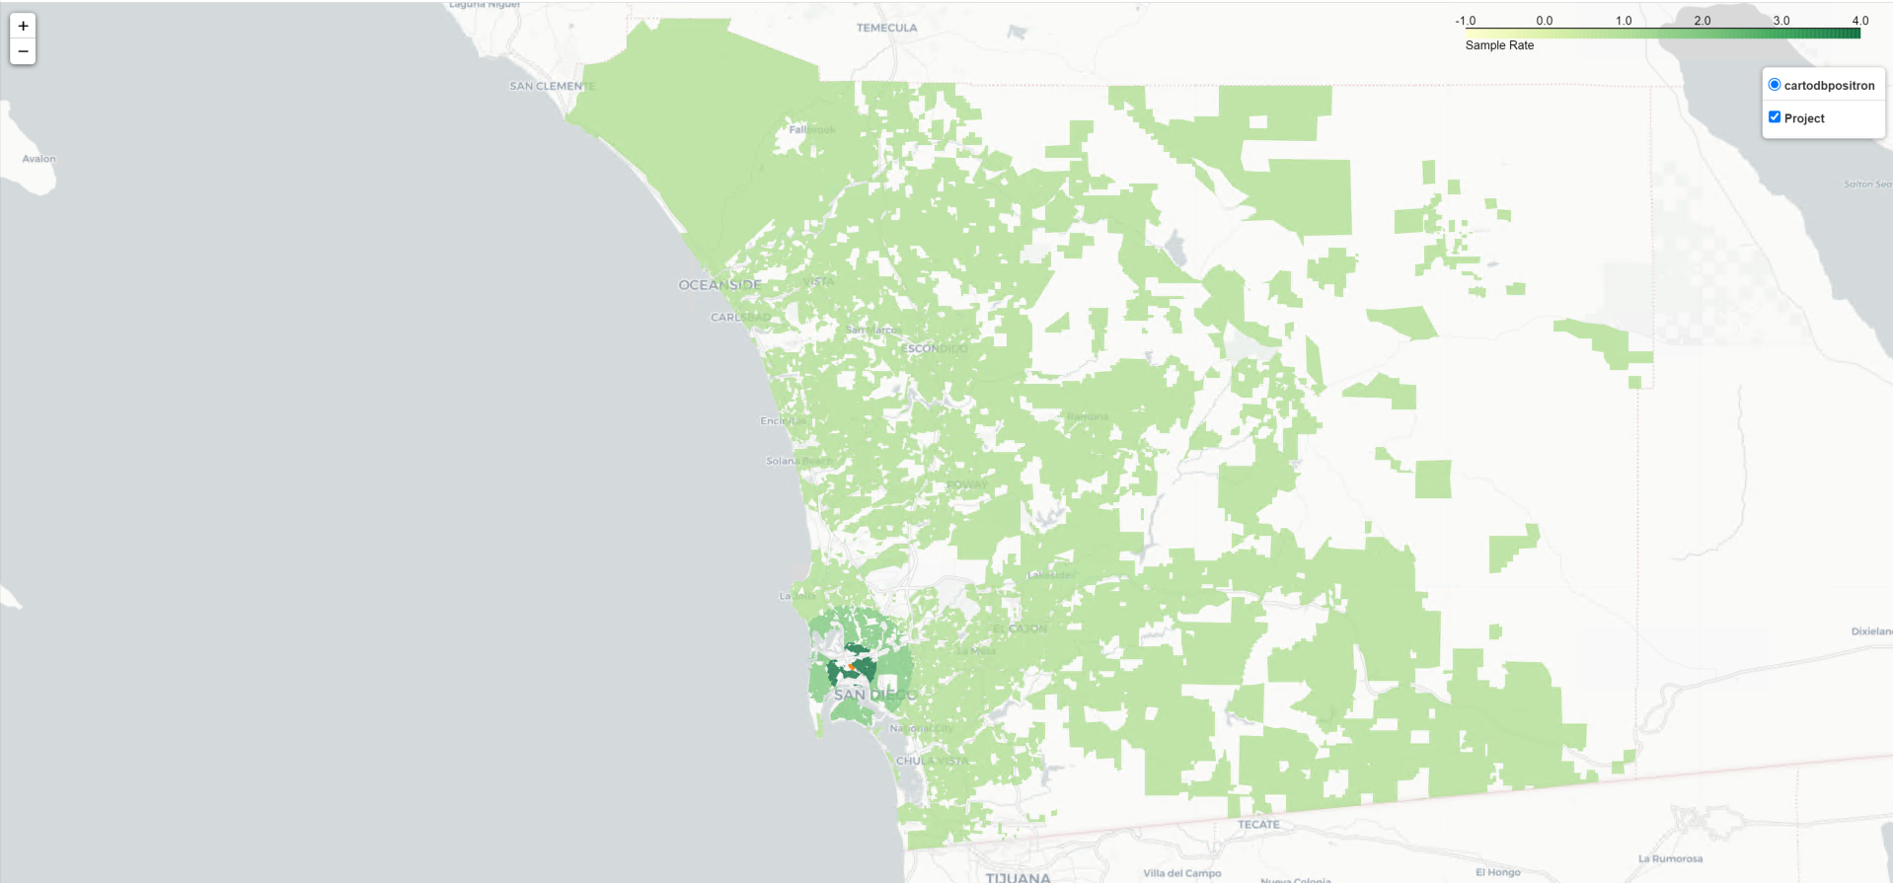
Figure 43: Sample Rate Map – NAVWAR
Figure 44: NAVWAR Household Sampling Check
- Run Models
At this point, all inputs are updated, and the two scenarios are setup as needed. Next, the user should run the two scenarios located under “abm_runs” with the standard procedure for running the ABM2+. The model setups would have the main model properties file (sandag_abm.properties) configured as necessary to run the model, however, before starting a run, the user should make sure that the Emme GUI has correct steps set to do a full model run. If a select link is desired, the user needs to enter the information as needed in the GUI.


Other releases may be found here: https://github.com/conda-forge/miniforge/releases.
In the case where original SANDAG No-Build was re-run only for a selected step, the properties file might be setup to run only those steps and not for a full model run.

